CSS BRITISH HISTORY · TOPIC 9 · KNOWLEDGE BASE
Thatcher and Major (1979–1997)
Eighteen years of Conservative government — Margaret Thatcher and Thatcherism, the Falklands War, the miners' strike, the end of the Cold War, John Major, Maastricht and Black Wednesday, and Britain's long argument with Europe, carried on to 2026

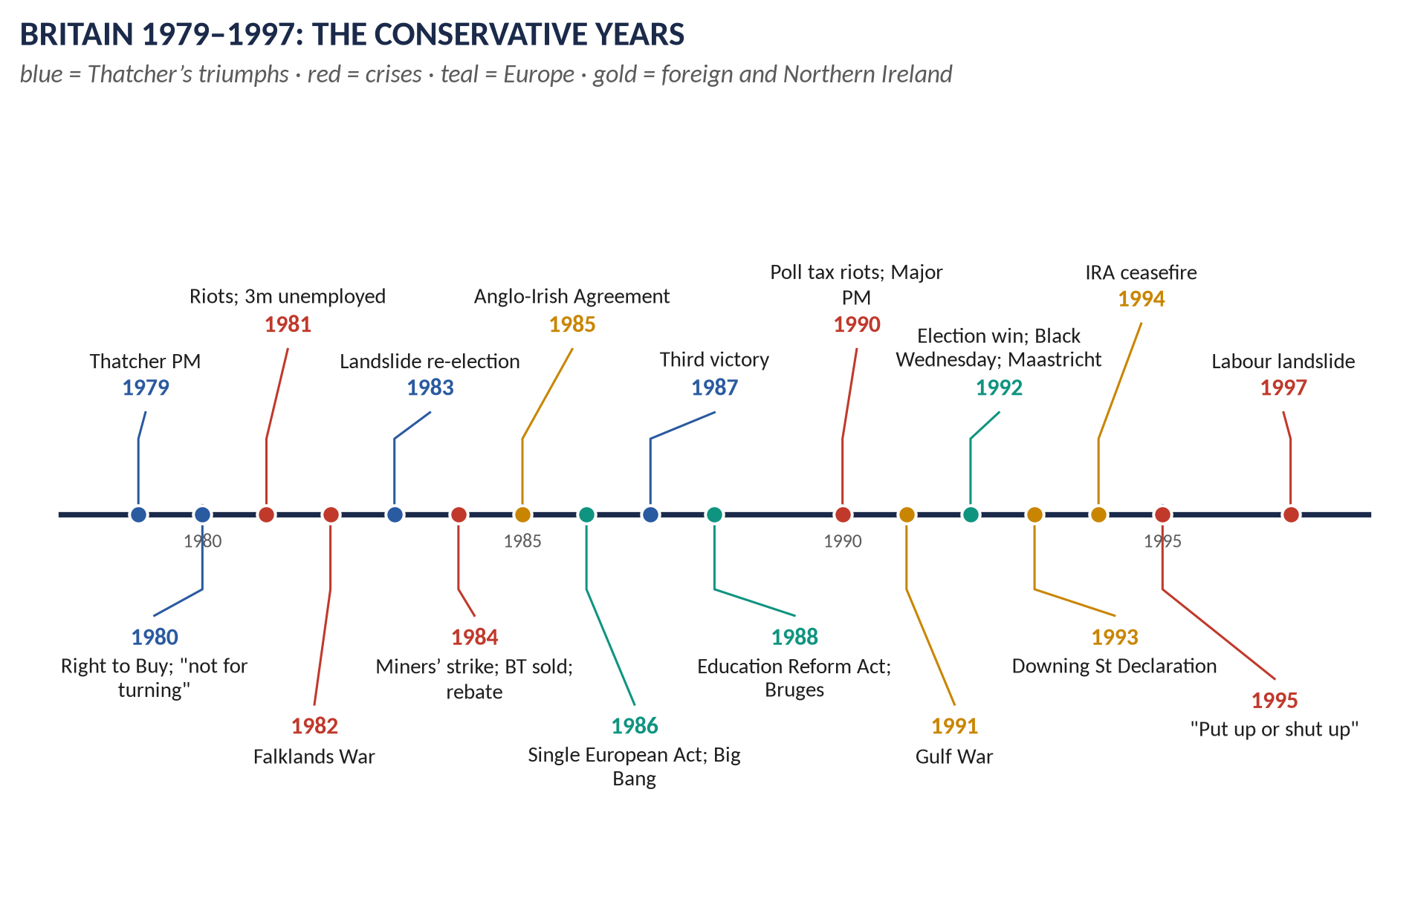
Syllabus head XIV. 11 past items in 2015–2026 — the Falklands 4, Europe 3, Thatcher 2, Major 2 — and 4 MCQs. Told from zero, then six chapters covering the whole head, with 120 one-liners and a stand-alone revision sheet.
Topic 9 of 10 · read with the companion document T9QA
Contents
HOW TO USE THIS · Updating the contents
Right-click the contents → Update Field → Update entire table, before saving as PDF.

How to Use This Document 5
What this Topic covers 5
Part Zero — The ABC Before the Story 6
0.1 Britain in 1979 — the simple picture 6
0.2 The words you need 6
Part One — The Story 8
1.1 The first Thatcher government (1979–1983) 8
1.2 The high tide (1983–1987) 8
1.3 The fall of Thatcher (1987–1990) 8
1.4 John Major (1990–1997) 8
Part Two — The Cast and the Time-line 10
2.1 The cast 10
2.2 The time-line 11
Part Three — The Chapters 12
Chapter 1 · Margaret Thatcher and Thatcherism 13
1.1 Who was Margaret Thatcher? 13
1.2 What was Thatcherism? 13
(i) Its main elements 14
(ii) Its roots 14
1.3 Economic reforms 15
(i) Monetarism and the recession (1979–1982) 15
(ii) Privatisation 15
(iii) Deregulation and the City 15
(iv) The Lawson boom and bust 15
(v) The unions and the miners 16
(vi) Housing — the Right to Buy 16
(vii) Local government and the poll tax 16
1.4 Educational reforms 16
1.5 Foreign and defence policy 17
1.6 Her fall (1990) 17
1.7 Was she the best post-war Prime Minister? 17
Chapter 2 · The Falklands War, 1982 19
2.1 The islands 19
2.2 The sovereignty dispute (1690–1980) 19
2.3 The causes of the war 20
(i) Long-term 20
(ii) British signals of weakness 20
(iii) The Argentine junta 20
(iv) The trigger 20
2.4 The invasion and Britain's response 20
Why Britain fought — "why did the British invade?" 20
2.5 Diplomacy fails 21
2.6 The war 21
2.7 How the war ended — and its consequences 21
2.8 The effect on relations with Latin America 22
Chapter 3 · John Major (1990–1997) 23
3.1 Who was John Major? 23
3.2 Domestic policy 23
3.3 The 1992 election (9 April 1992) 23
3.4 The collapse (1992–1997) 24
3.5 The 1997 election (1 May 1997) 24
3.6 Major's foreign policy 24
Chapter 4 · Britain and Europe, 1946–2026 26
4.1 Britain's contribution to the formation of European institutions 26
(i) The builder (1946–1955) 26
(ii) Staying out (1950–1960) 26
(iii) Joining (1961–1975) 26
(iv) The member (1973–1992) 27
(v) Maastricht and the European Union (1991–1993) 27
(vi) The euro opt-out (1992–2003) 27
(vii) To Brexit and after (2004–2026) 27
4.2 The impact on British foreign policy 28
4.3 The impact on British politics and identity since 1973 28
(i) Politics 28
(ii) Identity 28
Chapter 5 · Northern Ireland and the End of the Cold War (1979–1997) 30
5.1 Northern Ireland 30
5.2 The end of the Cold War 30
Chapter 6 · The Legacy — to 2026 31
Part Four — Historians and Quotations 32
Part Five — The Examiner's Record 33
Part Six — The One-Liner Bank 34
One-liners · Thatcher and Thatcherism 34
One-liners · The Falklands War 35
One-liners · John Major 36
One-liners · Britain and Europe 37
Part Seven — Revision Sheet · Topic 9: Thatcher and Major 39
R9.1 Thatcher and Thatcherism 39
R9.2 Economic reforms 39
R9.3 Educational reforms and impacts 39
R9.4 Best post-war PM? 39
R9.5 The Falklands War 40
R9.6 John Major 40
R9.7 Britain and Europe 40

How to Use This Document

What this Topic covers
Topic 9 covers 1979 to 1997 — the governments of Margaret Thatcher (1979–1990) and John Major (1990–1997). It is syllabus Head XIV: domestic policy, the Falklands War, the end of the Cold War, and Britain and Europe — from the Common Market to the Maastricht Treaty and the euro, with the story of Europe carried on to Brexit and 2026.
WHAT THE EXAMINER HAS ASKED · Why this topic matters
11 items in 2015–2026 and 4 MCQs. The Falklands is the examiner's favourite (2020 and 2022 — the same question — 2021, and a 2024 short note). Europe (2018 sn, 2021, 2026). Thatcher (2016, 2024). Major (2019; 2026 short note on his foreign policy).

THE STORY IN SIMPLE WORDS · Where this topic fits in the story
Topic 8 ended with the "Winter of Discontent" (1978–79), when strikes seemed to show that Britain had become ungovernable. Topic 9 tells how Thatcher broke with the post-war consensus — the welfare state, full employment, powerful unions, state industries — and remade Britain on free-market lines, and how Major struggled with the consequences, especially over Europe. Topic 10 continues with Tony Blair (1997).

Part Zero — The ABC Before the Story

0.1 Britain in 1979 — the simple picture
- The "sick man of Europe": slow growth, high inflation (prices rising fast — over 13 per cent in 1979), frequent strikes, loss-making state industries (coal, steel, British Leyland cars).
- The post-war consensus (1945–79): both parties accepted the welfare state, full employment, strong unions and a "mixed economy" of private and state firms. It seemed to have failed.
- Powerful unions: over 13 million members; strikes had helped bring down Heath (1974) and Callaghan (1979).
- The Cold War continued; Britain was in the EEC (since 1973) and NATO.

0.2 The words you need
Word | What it means, simply
Thatcherism | Margaret Thatcher's ideas: free markets, low taxes, privatisation, weaker unions, a smaller state, strong defence and national pride.
Monetarism | The idea that controlling the amount of money in the economy is the way to defeat inflation.
Inflation | Rising prices — money buys less each year.
Privatisation | Selling state-owned industries (telephones, gas, water) to private shareholders.
Deregulation | Removing government rules on business (e.g. the City's "Big Bang", 1986).
Right to Buy | Council tenants' right to buy their homes at a discount (1980).
Poll tax | The "Community Charge" (1989–90): a flat local tax on every adult — deeply unpopular.
Junta | A military government — Argentina's rulers in 1982.
Sovereignty | Supreme authority — who has the final say over a territory or over laws.
Self-determination | The right of a people to choose how and by whom they are governed.
ERM | The European Exchange Rate Mechanism: a system keeping European currencies close to each other in value.
Maastricht Treaty | The treaty (1992) that created the European Union and planned the single currency.
Opt-out | An exemption from part of a treaty — Britain's from the euro and the Social Chapter.
Euro | The single European currency (launched 1999; notes and coins 2002).
Euroscepticism | Distrust of European integration.
Sleaze | Political scandal and corruption — a charge against Major's government.

KEY IDEA · The one idea to hold on to
Thatcher set out to reverse Britain's decline by freeing markets and curbing the unions and the state. Her reforms made Britain more prosperous, more entrepreneurial and more unequal, and they lasted — Labour under Blair kept most of them. But the one issue her party could never settle was Europe: it helped bring down Thatcher in 1990, wrecked Major's government, and led in the end to Brexit.

Part One — The Story
THE STORY IN SIMPLE WORDS · The story in simple words
Read this Part first, straight through. Every event is explained in detail in the chapters.

1.1 The first Thatcher government (1979–1983)
Margaret Thatcher, a grocer's daughter from Grantham and Britain's first woman Prime Minister, won the election of May 1979 for the Conservatives. She cut income tax, raised VAT, and squeezed the money supply to fight inflation. The result was a deep recession: factories closed and unemployment passed 3 million. There were riots in Brixton and Toxteth (1981). She refused to change course: "The lady's not for turning" (1980). Then, in April 1982, Argentina seized the Falkland Islands. Thatcher sent a naval task force, which recaptured them by 14 June 1982. The victory, and a divided Labour Party, gave her a landslide in 1983.

1.2 The high tide (1983–1987)
Thatcher defeated the miners' strike (1984–85), sold state industries — British Telecom (1984), British Gas (1986) — to millions of small shareholders, and freed the City of London ("Big Bang", 1986). An IRA bomb at Brighton (October 1984) nearly killed her. Abroad she was Ronald Reagan's closest ally and said of Mikhail Gorbachev, "We can do business together." She won a third election in 1987.

1.3 The fall of Thatcher (1987–1990)
Her third government reformed education (1988) and the NHS, but the poll tax (1989–90) caused riots, the economy overheated, and her hostility to European integration split her cabinet. When her deputy Sir Geoffrey Howe resigned with a devastating speech (November 1990), Michael Heseltine challenged her; she resigned on 22 November 1990.

1.4 John Major (1990–1997)
The quiet John Major replaced her. He scrapped the poll tax, fought the Gulf War (1991), negotiated opt-outs at Maastricht (1991), and surprisingly won the 1992 election. But in September 1992 the pound crashed out of the ERM ("Black Wednesday"), destroying the Conservatives' reputation for managing the economy. His party tore itself apart over Europe, and scandals ("sleaze") followed. Meanwhile Tony Blair remade Labour as "New Labour". On 1 May 1997 Labour won a landslide.
VERDICT · The story in one sentence
Between 1979 and 1997 Thatcher broke the post-war consensus and remade Britain on free-market lines, won the Falklands War and helped end the Cold War, but divided the nation and her party; Major kept the Conservatives in power in 1992, but Black Wednesday, Europe and sleaze delivered Britain to New Labour in 1997.

Part Two — The Cast and the Time-line

2.1 The cast
Person | Dates / office | Who they were — in one line
Margaret Thatcher | PM 1979–90 | Britain's first woman PM; "the Iron Lady".
Sir Geoffrey Howe | Chancellor 1979–83; Foreign Sec. 1983–89 | His resignation speech (1990) triggered her fall.
Nigel Lawson | Chancellor 1983–89 | Tax cuts; the "Lawson boom"; resigned over Europe.
Michael Heseltine | 1933– | Resigned over Westland (1986); challenged Thatcher (1990).
Kenneth Baker | Education Sec. 1986–89 | The Education Reform Act (1988).
Arthur Scargill | Miners' leader | Led the 1984–85 miners' strike.
Neil Kinnock | Labour leader 1983–92 | Modernised Labour; lost in 1987 and 1992.
John Major | PM 1990–97 | Won 1992; Maastricht; Black Wednesday; lost 1997.
Norman Lamont | Chancellor 1990–93 | Chancellor on Black Wednesday.
John Smith | Labour leader 1992–94 | His shadow budget (1992) was used against Labour.
Tony Blair | Labour leader from 1994 | Created "New Labour"; won in 1997.
Leopoldo Galtieri | Argentine leader 1981–82 | Ordered the invasion of the Falklands.
Lord Carrington | Foreign Sec. 1979–82 | Resigned after the invasion.
Ronald Reagan | US President 1981–89 | Thatcher's close ally.
Mikhail Gorbachev | Soviet leader 1985–91 | "We can do business together."
Jacques Delors | Commission President 1985–95 | The drive for a federal Europe; Thatcher's opponent.

2.2 The time-line
Figure 1 · Britain 1979–1997.

Part Three — The Chapters

Chapter 1 · Margaret Thatcher and Thatcherism

1.1 Who was Margaret Thatcher?
Years | Event
1925 | Born Margaret Roberts in Grantham, Lincolnshire, daughter of a grocer and Methodist lay preacher who was also a local councillor.
1943–47 | Oxford (chemistry); later qualified as a barrister.
1959 | MP for Finchley.
1970–74 | Education Secretary under Heath — ended free school milk for older children ("Thatcher, milk snatcher").
1975 | Defeated Heath to become Conservative leader.
1976 | A Soviet newspaper called her "the Iron Lady" — she welcomed the name.
May 1979 | Prime Minister — Britain's first woman PM — with a majority of 43.
1983 | Re-elected with a majority of 144.
1987 | Re-elected with a majority of 102 — the first PM since 1820s to win three elections in a row.
22 Nov 1990 | Resigned after a leadership challenge.
2013 | Died 8 April; ceremonial funeral at St Paul's.

1.2 What was Thatcherism?
Thatcherism is the name for Margaret Thatcher's political ideas and policies. The political scientist Andrew Gamble summed it up as "the free economy and the strong state".
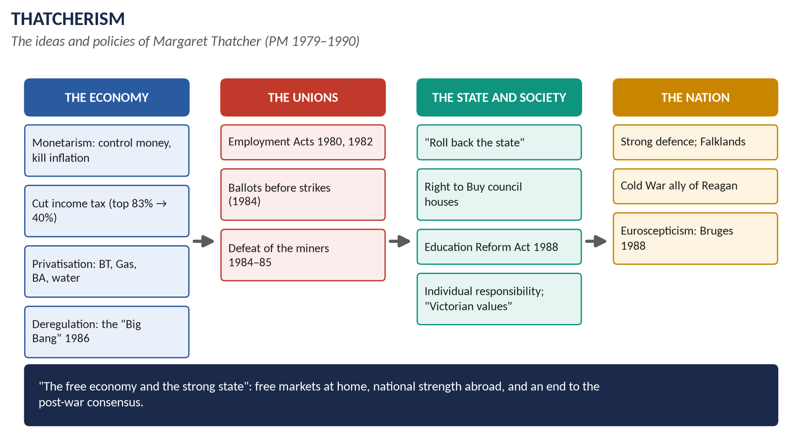
Figure 2 · Thatcherism.

(i) Its main elements
1. Monetarism: inflation is caused by too much money; control the money supply (influenced by Milton Friedman) rather than aim for full employment.
2. Free markets: private enterprise, not the state, creates wealth (influenced by Friedrich Hayek); privatisation and deregulation.
3. Low taxes: especially income tax, to reward enterprise.
4. "Rolling back the frontiers of the state": less spending, fewer subsidies to failing industries.
5. Curbing union power: unions had become too strong, damaging the economy and democracy.
6. The individual and the family: self-reliance, thrift, "Victorian values"; "there is no such thing as society. There are individual men and women and there are families" (1987).
7. A property-owning democracy: council-house sales and wider share ownership.
8. A strong state: law and order, strong defence, firm against the IRA and the unions.
9. National pride and sovereignty: the Falklands; hostility to a federal Europe.
10. Conviction politics: rejecting the consensus — "I am not a consensus politician. I am a conviction politician."

(ii) Its roots
The failures of the 1970s (inflation, strikes, the IMF loan); the thinkers of the "New Right" (Hayek, Friedman); Sir Keith Joseph and the Centre for Policy Studies (1974); her own upbringing in Grantham.

1.3 Economic reforms

(i) Monetarism and the recession (1979–1982)
- Geoffrey Howe's first budget (June 1979): income tax cut (basic rate 33p → 30p; top rate 83p → 60p); VAT raised from 8 to 15 per cent; exchange controls abolished (October 1979).
- High interest rates (17 per cent in 1979–80) and spending cuts to control money.
- The recession of 1980–81: manufacturing output fell by about a sixth; unemployment rose above 3 million by 1982 (and stayed there until 1987).
- 364 economists wrote to The Times (1981) condemning the policy; Thatcher refused to change: "The lady's not for turning" (Conservative conference, October 1980).
- Riots: Brixton (April 1981), Toxteth in Liverpool (July 1981) and elsewhere.
- Inflation fell from about 22 per cent (1980) to under 5 per cent (1983).

(ii) Privatisation
Year | Company sold
1979–81 | Part of BP; British Aerospace; Cable & Wireless
1984 | British Telecom — the first great flotation; over 2 million buyers
1986 | British Gas ("Tell Sid" advertising campaign)
1987 | British Airways; Rolls-Royce; the British Airports Authority
1988 | British Steel
1989 | The regional water companies
1990–91 | The electricity companies

- Aims: efficiency through competition; money for the Treasury (about £29 billion by 1990); wider share ownership (shareholders rose from about 3 million to about 11 million).
- Criticism: "selling the family silver" (Harold Macmillan, 1985); private monopolies; job losses.
- Thatcher is the Prime Minister most closely associated with privatisation.

(iii) Deregulation and the City
- The "Big Bang" (27 October 1986): the rules of the London Stock Exchange were abolished; computer trading; foreign banks moved in — London became a great global financial centre.
- Controls on credit and mortgages removed.

(iv) The Lawson boom and bust
- Nigel Lawson (Chancellor 1983–89) cut taxes: basic rate to 25p, top rate to 40p (1988).
- The economy boomed (1986–88): house prices soared; then inflation returned (10 per cent in 1990), interest rates rose to 15 per cent, and recession followed (1990–92).

(v) The unions and the miners
- Laws: the Employment Acts (1980, 1982) restricted secondary picketing and closed shops; the Trade Union Act (1984) required secret ballots before strikes and for union elections.
- The miners' strike (March 1984 – March 1985): the National Coal Board planned to close about 20 pits; the National Union of Mineworkers under Arthur Scargill struck — without a national ballot, which divided miners (Nottinghamshire kept working). The government had built up coal stocks and used police on a national scale; the "Battle of Orgreave" (June 1984). After a year the miners returned to work, defeated. Thatcher called the militants "the enemy within".
- Results: union membership fell from about 13 million (1979) to under 10 million (1990); strikes became rare; coal mining shrank (about 170 pits in 1984; almost none by 1994).
- Wapping (1986): Rupert Murdoch's newspapers broke the print unions.

(vi) Housing — the Right to Buy
- The Housing Act (1980) gave council tenants the right to buy their homes at discounts of up to 50 per cent (later more).
- Over 1 million homes were sold by the late 1980s; home ownership rose from about 55 to about 67 per cent.
- But councils were not allowed to build replacements — a cause of later housing shortages.

(vii) Local government and the poll tax
- The Greater London Council and the metropolitan counties were abolished (1986).
- The Community Charge — the "poll tax" — replaced local rates with a flat charge on every adult (Scotland 1989, England and Wales April 1990). A duke and a dustman paid the same. It caused mass non-payment and the poll tax riot in London (31 March 1990). Major abolished it (Council Tax, 1993).

1.4 Educational reforms
- The GCSE (announced 1984; first taught 1986, first exams 1988) replaced O-levels and CSEs.
- The Education Reform Act (1988, Kenneth Baker) — the biggest education law since 1944:
1. The National Curriculum: the same core subjects (English, maths, science) for all state schools in England and Wales. 2. National testing at ages 7, 11 and 14 (the "SATs"). 3. Local Management of Schools: budgets given to head teachers and governors. 4. Grant-maintained schools: schools could opt out of local-authority control, funded directly from London. 5. City Technology Colleges: new independent-state schools with business sponsors. 6. Parental choice: open enrolment; later school league tables (1992). 7. The Inner London Education Authority abolished; university tenure ended; polytechnics freed from local councils.
- Universities: spending cuts (1981); later expansion.
- Aims: higher standards, choice, accountability, less local-authority (often Labour) control.
- Impacts: common standards and more information for parents; but more central control, heavy testing, teacher discontent (strikes 1985–86) and wider gaps between schools.

1.5 Foreign and defence policy
- The Falklands War (1982) — Chapter 2.
- The Cold War: close partnership with Ronald Reagan; US cruise missiles in Britain (1983; the Greenham Common protests); support for the US bombing of Libya (1986); Trident. But she protested at the US invasion of Grenada (1983).
- Gorbachev: "I like Mr Gorbachev. We can do business together" (December 1984); she encouraged Reagan to negotiate; the Cold War ended (1989–91).
- Hong Kong: the Sino-British Joint Declaration (1984).
- Northern Ireland: the hunger strikes (1981; Bobby Sands died); the IRA's Brighton bomb (12 October 1984) killed five at the Conservative conference; the Anglo-Irish Agreement (1985) gave the Irish government a consultative role.
- Europe: see Chapter 4 — the rebate (1984), the Single European Act (1986), the Bruges speech (1988).
- Southern Africa: she opposed sanctions against apartheid South Africa, isolating Britain in the Commonwealth.

1.6 Her fall (1990)
1. The poll tax riots and by-election defeats.
2. Economic trouble: inflation and high interest rates (1989–90).
3. Europe: Lawson (1989) and Howe resigned over her hostility to European integration; Howe's resignation speech (13 November 1990) compared her to a captain who broke the bats of her own batsmen.
4. Style: domineering, ignoring cabinet colleagues.
5. Heseltine's challenge: she fell four votes short of outright victory in the first ballot; cabinet ministers told her she would lose; she withdrew (22 November 1990). John Major won the contest.

1.7 Was she the best post-war Prime Minister?
For | Against
Defeated inflation; ended the "British disease" of strikes | Mass unemployment (over 3 million for five years); deindustrialisation
Transformed the economy: enterprise, the City, privatisation | Inequality rose sharply; the north–south divide; poverty
Won three elections in a row; PM for 11½ years (the longest since 1827) | Divided the nation: the miners, riots, the poll tax
Falklands victory; world influence; helped end the Cold War | Neglected manufacturing; the housing shortage
Changed the consensus: New Labour kept her reforms | Split her party over Europe; brought down by her own cabinet
First woman PM | "No such thing as society"

- Historians' polls (e.g. of academics, 2004, 2010, 2016) usually rank Clement Attlee first, with Thatcher second — Attlee for creating the welfare state, Thatcher for her transformation of the economy.
- Consensus: she was the most transformative and important post-war Prime Minister; whether she was the best depends on whether one values her results or counts their social cost.
WHAT THE EXAMINER HAS ASKED · Where Chapter 1 has been asked
2016 Q6 (the best post-war PM?) · 2024 Q5 (Thatcherism; economic and educational reforms and their impacts). MCQs 2025: privatisation → Thatcher; the 1984–85 strike was led by the miners; 2026: the first woman PM was Conservative.

Chapter 2 · The Falklands War, 1982
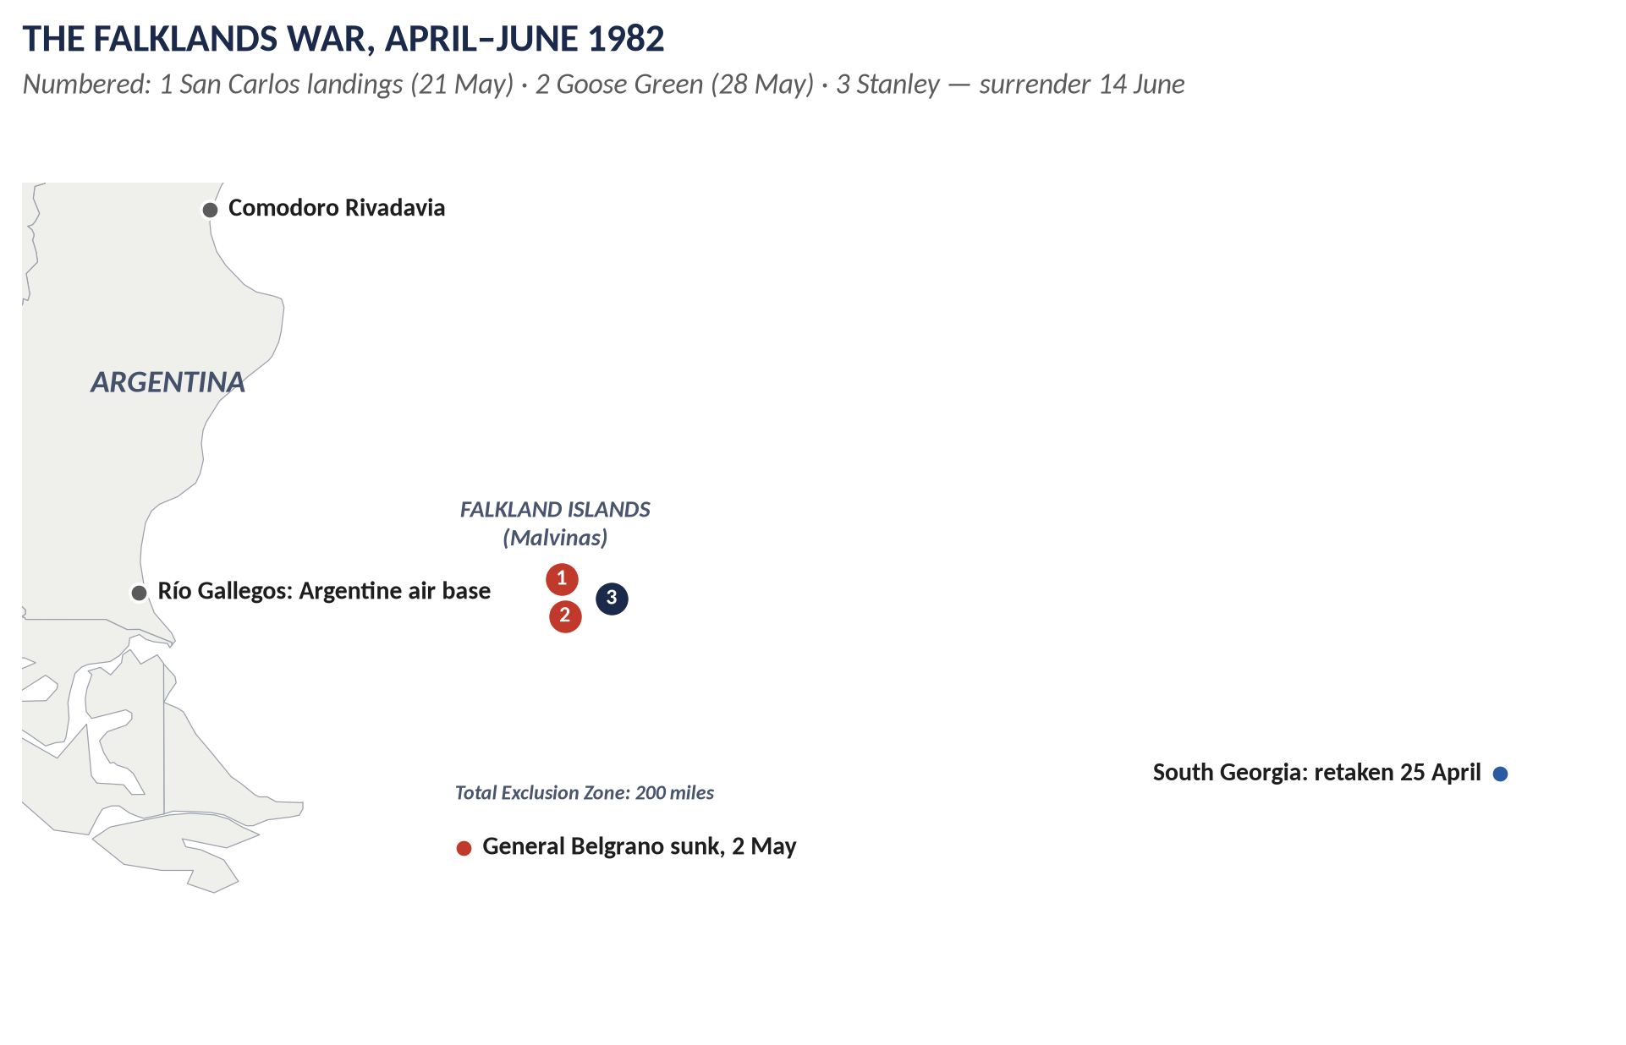
Figure 3 · The Falklands War.

2.1 The islands
- About 500 km east of Argentina in the South Atlantic; two main islands (East and West Falkland) and hundreds of small ones; capital Stanley.
- About 1,800 people in 1982, almost all of British descent, living from sheep farming.
- Argentina calls them Las Malvinas.

2.2 The sovereignty dispute (1690–1980)
- Claims: a British captain named them (1690); French, British and Spanish settlements in the 18th century.
- Argentina's claim: it inherited Spain's rights on independence (1816) and set up a settlement in the 1820s.
- 1833: Britain took control and expelled the Argentine garrison; British settlers came. Argentina has protested ever since.
- The UN: Resolution 2065 (1965) called on Britain and Argentina to negotiate. Talks continued for years, but the islanders refused any transfer, and Parliament backed them.
- Lease-back (1980): minister Nicholas Ridley proposed giving Argentina sovereignty and leasing the islands back — rejected by the islanders and MPs.

2.3 The causes of the war

(i) Long-term
The unresolved sovereignty dispute; Argentine national feeling about the "Malvinas", taught in every school.

(ii) British signals of weakness
1. The 1981 Defence Review (John Nott) planned to withdraw the ice patrol ship HMS Endurance, Britain's only naval presence.
2. The British Nationality Act (1981) did not give the islanders full British citizenship.
3. Years of talks suggested Britain wanted to get rid of the islands.

(iii) The Argentine junta
- General Leopoldo Galtieri's military government faced economic crisis (inflation over 100 per cent), protests and the anger over the "Dirty War" disappearances.
- A quick victory would unite the nation, especially before the 150th anniversary of British rule (1983).
- The junta believed Britain would not fight so far away, and that the USA would stay neutral or support Argentina.

(iv) The trigger
On 19 March 1982 Argentine scrap-metal workers landed on South Georgia and raised the Argentine flag.

2.4 The invasion and Britain's response
- 2 April 1982: Argentine forces invaded (Operation Rosario); the small Royal Marines garrison surrendered. South Georgia fell on 3 April.
- 3 April: UN Security Council Resolution 502 demanded Argentine withdrawal.
- 5 April: the Foreign Secretary Lord Carrington resigned; a naval task force sailed with the carriers Hermes and Invincible.

Why Britain fought — "why did the British invade?"
(Strictly, Argentina invaded; Britain sent forces to retake the islands.)
1. Self-determination: the islanders were British and wished to remain so.
2. Aggression must not be rewarded: an armed seizure of territory broke international law (Resolution 502).
3. National pride and credibility: surrender would humiliate Britain and encourage other aggressors — important in the Cold War.
4. Thatcher's conviction: she saw it as a matter of principle; her government's survival was also at stake.
5. Public and parliamentary support: an emergency Commons debate (3 April) demanded action.

2.5 Diplomacy fails
- US mediation: Alexander Haig's shuttle diplomacy (April) failed; the USA then backed Britain (30 April) with intelligence, fuel and missiles (Sidewinders).
- The Peruvian peace plan failed after the sinking of the Belgrano.
- The EEC imposed sanctions on Argentina; most Latin American states supported Argentina; Chile secretly helped Britain.

2.6 The war
Date | Event
12 April | A 200-mile Maritime (later Total) Exclusion Zone.
25 April | South Georgia retaken.
1 May | RAF Vulcan bombers raid Stanley airfield.
2 May | The submarine Conqueror sank the Argentine cruiser General Belgrano — 323 dead; controversial because the ship was outside the zone and sailing away. The Argentine navy stayed in port.
4 May | HMS Sheffield sunk by an Exocet missile.
21 May | Landings at San Carlos; heavy air attacks (HMS Ardent, Antelope, Coventry and the Atlantic Conveyor lost).
28 May | Goose Green captured by 2 Para.
8 June | The Sir Galahad bombed at Bluff Cove — about 50 dead.
11–14 June | Battles for the mountains around Stanley (Mount Longdon, Tumbledown, Wireless Ridge).
14 June 1982 | General Menéndez surrendered at Stanley.

Casualties: 255 British servicemen, 649 Argentines and 3 islanders died.

2.7 How the war ended — and its consequences
- Military end: the surrender of about 10,000 Argentine troops (14 June); prisoners returned.
- Argentina: Galtieri was forced out (17 June); the junta collapsed; democracy returned (Raúl Alfonsín, 1983).
- Britain: Thatcher's popularity soared — the "Falklands factor" helped her 1983 landslide; the Franks Report (1983) cleared the government of blame for the invasion.
- The islands: full British citizenship (1983); a large garrison and the Mount Pleasant air base (1985); a fishing and oil economy; the islanders became much richer.
- The dispute continues: Argentina has never given up its claim.

2.8 The effect on relations with Latin America
1. Argentina: diplomatic relations were broken (1982–1990), restored by the Madrid Declarations (1989–90) under a "sovereignty umbrella" (both sides kept their claims). Argentina's 1994 constitution declared the claim "permanent and unrenounceable". Tensions rose under the Kirchner presidents (2003–15) — oil exploration, fishing, protests at the UN. The islanders' referendum (March 2013) — 99.8 per cent voted to remain British. President Javier Milei (from December 2023) adopted a friendlier tone and sought cooperation while keeping the claim.
2. The region: in 1982 most Latin American states and the Organisation of American States backed Argentina's claim; the war revived resentment of "colonialism". Many still support Argentina diplomatically; the Mercosur states (2011) agreed to close their ports to ships flying the Falklands flag.
3. Chile — Argentina's rival — secretly helped Britain and has remained a close partner.
4. Brazil and others have built trade and diplomatic ties with Britain despite the dispute.
5. Arms: Britain restricts arms exports to Argentina.
6. Overall: the war made the Falklands a lasting irritant in Britain's relations with the region, though pragmatic trade and cooperation have grown.
WHAT THE EXAMINER HAS ASKED · Where Chapter 2 has been asked
2020 Q8 and 2022 Q6 (causes; effect on relations with Latin America — the same question) · 2021 Q6 (what the conflict was; why Britain fought; how it ended) · 2024 Q7(a) (short note).

Chapter 3 · John Major (1990–1997)
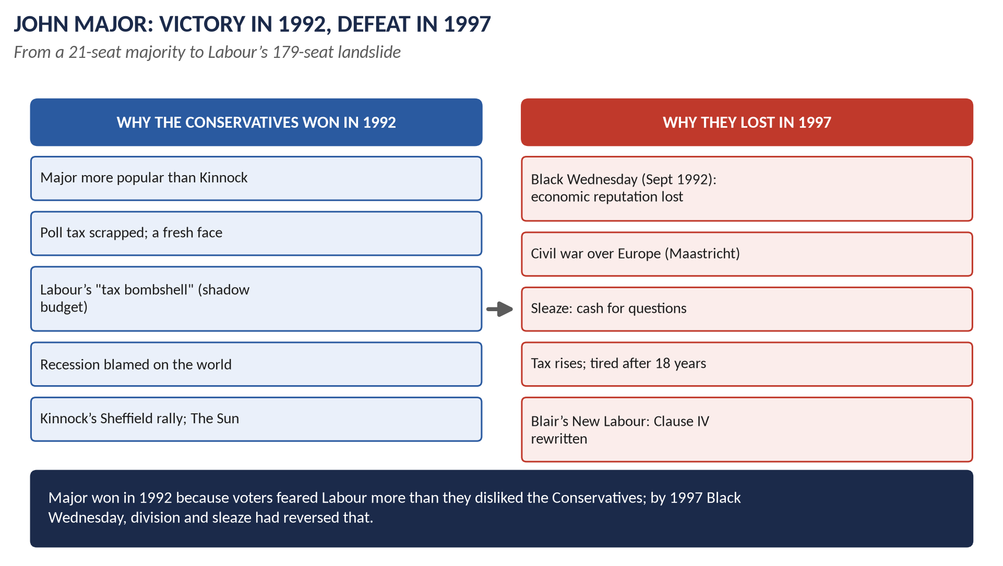
Figure 4 · Major: victory in 1992, defeat in 1997.

3.1 Who was John Major?
Born 1943, son of a music-hall performer; left school at 16; worked in banking; MP for Huntingdon (1979); Foreign Secretary and Chancellor (1989–90, when he took Britain into the ERM). As Prime Minister (November 1990 – May 1997) he offered a calmer, more consensual style than Thatcher: "a nation at ease with itself".

3.2 Domestic policy
- The poll tax abolished — replaced by the Council Tax (1993).
- The Citizen's Charter (1991): standards for public services.
- Privatisation continued: coal (1994), railways (1994–97 — unpopular).
- The National Lottery (1994).
- Education: the polytechnics became universities (1992); school league tables; Ofsted (1992).
- "Back to Basics" (1993): a campaign for traditional values — mocked when ministers were caught in scandals.

3.3 The 1992 election (9 April 1992)
- Result: Conservatives 336 seats (majority 21) with about 14 million votes — the most votes any party had ever won; Labour 271; Liberal Democrats 20.
- Why the Conservatives won:
1. Major's appeal: new, modest, likeable; his "soapbox" campaign. 2. The poll tax had been removed. 3. Fear of Labour's taxes: John Smith's "shadow budget" raised taxes on higher earners; the Conservatives' poster "Labour's Tax Bombshell" and "Double Whammy" (higher taxes and prices). 4. Doubts about Kinnock: the over-confident Sheffield rally (1 April); The Sun: "If Kinnock wins today will the last person to leave Britain please turn out the lights" — then "It's The Sun Wot Won It". 5. The recession was blamed on world conditions; voters trusted the Conservatives more on the economy. 6. Labour's past: memories of the 1970s and the divisions of the 1980s.

3.4 The collapse (1992–1997)
1. Black Wednesday (16 September 1992): speculators sold the pound; the government raised interest rates from 10 to 12 and then 15 per cent in a day and spent billions of reserves, but had to leave the ERM. The Conservatives' reputation for economic competence was destroyed — and never recovered, even though the economy then grew strongly.
2. Tax rises: Lamont and Kenneth Clarke raised taxes, including VAT on domestic fuel (1994) — breaking election promises.
3. Europe: the Maastricht rebels (1992–93); Major's private remark calling three cabinet Eurosceptics "bastards" (1993); the whip withdrawn from eight MPs (1994); Major's "put up or shut up" leadership election (1995), which he won against John Redwood; the Referendum Party (1994) and UKIP (1993) took votes.
4. Sleaze: "cash for questions" (1994) — MPs paid to ask questions (Neil Hamilton); Jonathan Aitken (later jailed for perjury); sexual scandals after "Back to Basics"; the Nolan Committee on standards (1994).
5. The BSE ("mad cow") crisis (1996): a worldwide ban on British beef.
6. New Labour: Tony Blair (leader from 1994) rewrote Clause IV (1995), promised not to raise income tax, courted business and The Sun (which backed him in 1997), and looked fresh and moderate.
7. Tiredness: after 18 years, "time for a change"; tactical voting against Conservatives.

3.5 The 1997 election (1 May 1997)
Labour 418 seats, Conservatives 165 (their worst result since 1906), Liberal Democrats 46; a Labour majority of 179. Seven cabinet ministers lost their seats.

3.6 Major's foreign policy
- The Gulf War (January–February 1991): about 45,000 British troops in the US-led coalition that freed Kuwait; Major proposed the safe havens for the Kurds in northern Iraq and the no-fly zones.
- Europe: Maastricht (December 1991) — he won opt-outs from the single currency and the Social Chapter ("game, set and match"); he wanted Britain "at the very heart of Europe" (1991), but Black Wednesday and his party's divisions weakened him; the beef war (1996).
- Former Yugoslavia: British troops in the UN force (UNPROFOR) in Bosnia (1992–95); criticised for opposing arms for the Bosnians and slow action until Dayton (1995).
- Northern Ireland: the Downing Street Declaration (December 1993) with Irish PM Albert Reynolds; the IRA ceasefire (August 1994) — foundations for the Good Friday Agreement (1998).
- The USA: friendly with George H. W. Bush; tensions with Bill Clinton (over Bosnia and the visa for Gerry Adams, 1994).
- Russia: support for Yeltsin and reform; the end of the Cold War — defence cuts ("Options for Change").
- Hong Kong: Governor Chris Patten's reforms (1992–97) angered China; handover on 1 July 1997, weeks after Major left office.
- Assessment: competent and constructive (the Gulf, Northern Ireland, Maastricht opt-outs), but constrained by party divisions over Europe.
WHAT THE EXAMINER HAS ASKED · Where Chapter 3 has been asked
2019 Q8 (why the Conservatives won in 1992 but lost in 1997) · 2026 Q8(c) (short note: Major's foreign policy). MCQ 2024: Thatcher's successor was John Major.

Chapter 4 · Britain and Europe, 1946–2026
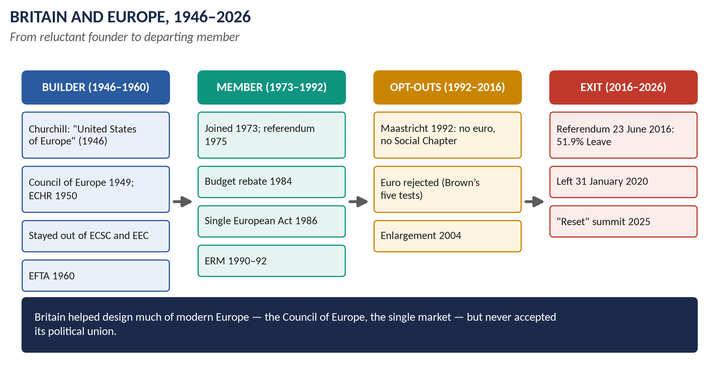
Figure 5 · Britain and Europe, 1946–2026.

4.1 Britain's contribution to the formation of European institutions

(i) The builder (1946–1955)
- Churchill's Zurich speech (1946) called for "a kind of United States of Europe" (with Britain as a friend, not a member).
- The Brussels Treaty (1948) and NATO (1949) — Bevin's work.
- The Council of Europe (1949): Britain was a founding member (Treaty of London); it produced the European Convention on Human Rights (1950), largely drafted by British lawyers (David Maxwell Fyfe).
- The OEEC (1948) to share Marshall Aid.
- The Western European Union (1954): Eden's solution to West German rearmament.

(ii) Staying out (1950–1960)
- Britain refused to join the European Coal and Steel Community (1951) and the EEC (Treaty of Rome, 1957), preferring the Commonwealth, the USA, national sovereignty and its own industries.
- It created the looser European Free Trade Association (EFTA, 1960).

(iii) Joining (1961–1975)
Applications in 1961 (Macmillan) and 1967 (Wilson) were vetoed by de Gaulle; Heath took Britain in on 1 January 1973; the referendum of 1975 confirmed it (67 per cent).

(iv) The member (1973–1992)
- The budget rebate (Fontainebleau, 1984): Thatcher's "I want my money back" won a permanent reduction in Britain's payments.
- The single market: Britain's great contribution — the Single European Act (1986), whose single-market programme was designed by the British commissioner Lord Cockfield; it removed barriers to trade in goods, services, capital and people by 1992.
- Enlargement: Britain championed bringing in the new democracies of Southern and later Eastern Europe.
- The Bruges speech (September 1988): Thatcher rejected "a European super-state exercising a new dominance from Brussels".
- The ERM (October 1990 – September 1992).

(v) Maastricht and the European Union (1991–1993)
- The Maastricht Treaty (agreed December 1991, signed February 1992) created the European Union (from 1 November 1993): economic and monetary union (the single currency), a common foreign and security policy, cooperation in justice and home affairs, European citizenship.
- Britain's opt-outs: from the single currency and the Social Chapter (workers' rights); the principle of subsidiarity (decisions at the lowest effective level) was a British demand.
- The ratification crisis (1992–93): Denmark's "No" (June 1992); Conservative rebels voted against the bill; Major had to call a vote of confidence (July 1993) to pass it.

(vi) The euro opt-out (1992–2003)
- Black Wednesday (1992) made the single currency politically toxic.
- Blair favoured the euro in principle, but Gordon Brown set five economic tests (October 1997); the Treasury concluded in 2003 that they were not met. Britain kept the pound.
- Blair signed the Social Chapter (1997).

(vii) To Brexit and after (2004–2026)
- Enlargement (2004): Britain opened its labour market to the new Eastern members at once; immigration rose sharply — a key issue later.
- The Lisbon Treaty (2007); UKIP's rise; David Cameron's Bloomberg speech (January 2013) promised a referendum.
- The referendum (23 June 2016): Leave 51.9 per cent, Remain 48.1 per cent. England and Wales voted Leave; Scotland (62 per cent Remain) and Northern Ireland (56 per cent Remain) voted Remain.
- Article 50 triggered (March 2017); years of deadlock; Boris Johnson's deal; Britain left on 31 January 2020; the Trade and Cooperation Agreement (December 2020); the Windsor Framework for Northern Ireland (2023).
- Keir Starmer (from 2024) sought a "reset": the UK–EU summit of May 2025 agreed a security and defence partnership and plans for closer cooperation, without rejoining the single market or customs union.

4.2 The impact on British foreign policy
1. From empire to Europe: membership replaced the Commonwealth as Britain's main economic and diplomatic framework (Acheson's "lost an empire").
2. A bridge between the USA and Europe: Britain used its EU membership to add weight in Washington and its US ties to add weight in Brussels.
3. Pooled trade policy: the EU negotiated trade deals for Britain.
4. A common foreign and security policy (from Maastricht): cooperation on sanctions (Iran, Russia), the Balkans, aid.
5. An awkward partner: Britain resisted federalism, won opt-outs, and was often isolated (the rebate, the euro).
6. After Brexit: "Global Britain" — new trade deals (Australia, Japan, CPTPP 2023), the AUKUS pact, a tilt to the Indo-Pacific; then renewed partnership with Europe over Ukraine and the 2025 reset.

4.3 The impact on British politics and identity since 1973

(i) Politics
- Party splits: Labour (the 1975 referendum; the SDP breakaway, 1981, partly over Europe); the Conservatives (Thatcher's fall, 1990; the Maastricht rebels; the 2016–19 civil war over Brexit).
- Prime ministers destroyed: Thatcher (1990), Major's authority (1992–97), Cameron (2016), May (2019).
- New parties: the Referendum Party (1994–97), UKIP (1993), the Brexit Party/Reform UK (2019 onwards).
- Referendums became part of the constitution (1975, 2016).
- Sovereignty: the Factortame case (1990) showed EU law could override Acts of Parliament.

(ii) Identity
- British or European? Most Britons, especially the English, felt "British, not European"; surveys showed one of the weakest European identities in the EU.
- Sovereignty and "taking back control": the central argument of Brexit.
- The nations: Scotland and Northern Ireland felt more European — Brexit strengthened Scottish nationalism and complicated the Irish border.
- Generations and places: the young, graduates and cities favoured Europe; older voters and post-industrial towns favoured leaving.
- Immigration: free movement after 2004 made immigration central to identity politics.
WHAT THE EXAMINER HAS ASKED · Where Chapter 4 has been asked
2018 Q8(b) (short note: Britain's role in the EU) · 2021 Q7 (Britain's contribution to the Common Market and the EU; impact on foreign policy) · 2026 Q6 (the impact of integration on politics and identity; Maastricht; the euro opt-out).

Chapter 5 · Northern Ireland and the End of the Cold War (1979–1997)

5.1 Northern Ireland
- The Troubles (from 1968–69): conflict between mainly Catholic nationalists/republicans (wanting a united Ireland) and mainly Protestant unionists/loyalists (wanting to stay in the UK); the IRA's armed campaign.
- 1979: the IRA killed Lord Mountbatten and 18 soldiers at Warrenpoint.
- The hunger strikes (1981): ten republican prisoners, including Bobby Sands (elected an MP during his strike), starved to death demanding political status; Thatcher refused.
- The Brighton bomb (October 1984).
- The Anglo-Irish Agreement (November 1985): Dublin given a consultative role — unionists furious ("Ulster says No").
- The Downing Street Declaration (December 1993, Major and Reynolds): Britain had "no selfish strategic or economic interest" in Northern Ireland; a united Ireland only by consent.
- The IRA ceasefire (August 1994), broken in 1996 (Canary Wharf), restored in 1997 → the Good Friday Agreement (1998, Topic 10).

5.2 The end of the Cold War
- Thatcher and Reagan: firm against the USSR (cruise missiles 1983); but she saw in Gorbachev (1984) a leader to negotiate with.
- 1989: the fall of the Berlin Wall (9 November) and the collapse of communism in Eastern Europe; Thatcher was wary of German reunification (1990).
- 1991: the collapse of the Soviet Union (December).
- For Britain: defence cuts ("Options for Change", 1990); a new focus on peacekeeping (Bosnia) and "rogue states" (Iraq).

Chapter 6 · The Legacy — to 2026
Theme | What happened later
Thatcherism | Blair's New Labour kept privatisation, union laws and low income tax; the 2008 financial crisis revived criticism of deregulation. Thatcher died in 2013.
Privatisation | Rail franchises returned to public ownership — Great British Railways planned; Labour's 2024–25 legislation began bringing train operators back into the public sector. Water companies criticised over sewage and debts (Thames Water crisis, 2024–25).
Right to Buy | Restricted in Scotland (ended 2016) and Wales (2019); housing shortages remain a major issue.
Education | The National Curriculum and testing survive; academies (from 2000) grew out of grant-maintained schools and CTCs.
The Falklands | 2013 referendum; Argentina's claim continues under Milei; the islands remain British.
Europe | Brexit (2020); the 2025 "reset".
Northern Ireland | The Good Friday Agreement (1998); power-sharing restored in 2024.

Part Four — Historians and Quotations
Historian or writer | The view to quote
Andrew Gamble, The Free Economy and the Strong State (1988) | Thatcherism as free markets plus a strong state.
Stuart Hall (1979) | Coined "Thatcherism"; "authoritarian populism".
Charles Moore (official biography, 2013–19) | A heroic, transformative leader.
Hugo Young, One of Us (1989); This Blessed Plot (1998) | Critical biography; Britain's troubled relationship with Europe.
Dennis Kavanagh | Thatcher ended the post-war consensus.
Lawrence Freedman, Official History of the Falklands Campaign (2005) | The war's causes and conduct.
Anthony Seldon, Major: A Political Life (1997) | Major more successful than he is given credit for.
Stephen George, An Awkward Partner (1990) | Britain as the EU's "awkward partner".

"Where there is discord, may we bring harmony." — Thatcher, 4 May 1979 (quoting St Francis)
"The lady's not for turning." — Thatcher, October 1980
"There is no such thing as society." — Thatcher, 1987
"Game, set and match." — attributed to Major's team after Maastricht, 1991
"We have not successfully rolled back the frontiers of the state in Britain, only to see them re-imposed at a European level." — Thatcher, Bruges, 1988

Part Five — The Examiner's Record
Paper | The question as set | Family | Type
2016 · Q6 · Section B | 'Margaret Thatcher is judged to be the best post-war Prime Minister of England.' Discuss. | Thatcher and Thatcherism | Quotation / claim
2018 · Q8(b) · Section B | Short note: Britain's role in the EU | Britain and Europe (EEC/EU) | Short note
2019 · Q8 · Section B | Explain why John Major and the Conservatives won the general election of 1992 but lost the election of 1997. | John Major | Causes / results
2020 · Q8 · Section B | What were the causes of the Falkland War? In what way has it affected Britain's relationship with Latin American countries? | The Falklands War | Causes / results
2021 · Q6 · Section B | What was the Falkland Islands conflict? Why did the British invade the Falkland Islands and how did this war come to an end? | The Falklands War | Causes / results
2021 · Q7 · Section B | What was the contribution of Great Britain to the formation of the European Common Market and the European Union? Also highlight its impact on the foreign policy of Britain. | Britain and Europe (EEC/EU) | Policy analysis
2022 · Q6 · Section B | Explain the genesis of the Falkland War. How has it affected Britain's relationship with Latin American countries? | The Falklands War | Causes / results
2024 · Q5 · Section B | Define the term 'Thatcherism'. Discuss Margaret Thatcher's economic and educational reforms and their impacts on people's lives. | Thatcher and Thatcherism | Policy analysis
2024 · Q7(a) · Section B | Short note: Falkland War | The Falklands War | Short note
2026 · Q6 · Section B | Discuss the impact of European integration on British politics and identity since 1973, with particular reference to the debates surrounding the Maastricht Treaty and the UK's opt-out from the euro. | Britain and Europe (EEC/EU) | Impact / significance
2026 · Q8(c) · Section B | Short note: John Major's foreign policy | John Major | Short note

WHAT THE EXAMINER HAS ASKED · The pattern
Falklands: causes and Latin America (2020, repeated 2022), what it was, why Britain fought, how it ended (2021), short note (2024). Europe: Britain's role (2018 sn), its contribution and the effect on foreign policy (2021), integration's impact on politics and identity with Maastricht and the euro (2026). Thatcher: "best post-war PM" (2016), Thatcherism and her economic and educational reforms (2024). Major: 1992 and 1997 (2019), foreign policy (2026 sn). Not yet set as full questions: the miners' strike, Northern Ireland, Thatcher's foreign policy and the end of the Cold War, the poll tax and her fall.

Part Six — The One-Liner Bank
HOW TO USE THIS · How to use the one-liners
Cover the answer after the arrow and say it aloud. 120 questions; bold words are the ones examiners test. The past MCQs are solved in T9QA.

One-liners · Thatcher and Thatcherism
1. Who was Britain's first woman Prime Minister? → Margaret Thatcher (1979–90).
2. Which party did she lead? → The Conservative Party.
3. Where was she born (1925)? → Grantham, Lincolnshire.
4. Which constituency did she represent? → Finchley.
5. What nickname did a Soviet newspaper give her? → "The Iron Lady".
6. What was she called for ending free school milk? → "Thatcher, milk snatcher".
7. When did she become Conservative leader? → 1975.
8. When did she win her three elections? → 1979, 1983, 1987.
9. Who described Thatcherism as "the free economy and the strong state"? → Andrew Gamble.
10. Which economist inspired monetarism? → Milton Friedman.
11. Which thinker inspired her free-market ideas? → Friedrich Hayek.
12. Which minister was her intellectual guide? → Sir Keith Joseph.
13. What did she say at the 1980 conference? → "The lady's not for turning."
14. To what did Howe raise VAT in 1979? → 15 per cent.
15. How high did unemployment rise in the early 1980s? → Over 3 million.
16. How many economists wrote against her policy in 1981? → 364.
17. Where were the major riots of 1981? → Brixton and Toxteth.
18. Which PM is most associated with privatisation? → Margaret Thatcher.
19. Which company was privatised in 1984? → British Telecom.
20. What was the advertising slogan for the British Gas sale? → "Tell Sid".
21. Who said privatisation was "selling the family silver"? → Harold Macmillan.
22. What was the "Big Bang" (1986)? → The deregulation of the City of London.
23. What did the Housing Act 1980 create? → The Right to Buy council houses.
24. Which Act (1984) required strike ballots? → The Trade Union Act.
25. Which group led the major 1984–85 strike? → The miners (NUM).
26. Who led the miners? → Arthur Scargill.
27. What was the violent clash of June 1984 called? → The Battle of Orgreave.
28. What did Thatcher call militant strikers? → "The enemy within".
29. Who was Chancellor during the late-1980s boom? → Nigel Lawson.
30. What was the top rate of income tax after 1988? → 40 per cent.
31. What was the poll tax officially called? → The Community Charge.
32. When was the poll tax riot in London? → 31 March 1990.
33. Which body in London did she abolish (1986)? → The Greater London Council.
34. What replaced O-levels (first exams 1988)? → The GCSE.
35. Which Act of 1988 created the National Curriculum? → The Education Reform Act.
36. Which minister passed it? → Kenneth Baker.
37. What could schools do under the Act? → Opt out (grant-maintained status).
38. What new schools did it create? → City Technology Colleges.
39. What did Thatcher say about society (1987)? → "There is no such thing as society."
40. What did she say of Gorbachev (1984)? → "We can do business together."
41. Which US President was her close ally? → Ronald Reagan.
42. Which invasion by the USA (1983) did she oppose? → Grenada.
43. Where did the IRA bomb the Conservative conference (1984)? → Brighton.
44. Which 1985 agreement gave Dublin a role in Northern Ireland? → The Anglo-Irish Agreement.
45. Which 1984 agreement settled Hong Kong's future? → The Sino-British Joint Declaration.
46. Whose resignation speech (1990) triggered her fall? → Sir Geoffrey Howe's.
47. Who challenged her for the leadership? → Michael Heseltine.
48. When did she resign? → 22 November 1990.
49. Who is usually ranked the best post-war PM by historians? → Clement Attlee (Thatcher usually second).
50. When did Thatcher die? → 8 April 2013.

One-liners · The Falklands War
51. What does Argentina call the Falklands? → Las Malvinas.
52. Since when have the islands been British-ruled? → 1833.
53. About how many islanders lived there in 1982? → About 1,800.
54. Which UN resolution (1965) called for negotiations? → Resolution 2065.
55. Which minister proposed lease-back (1980)? → Nicholas Ridley.
56. Which ship's planned withdrawal signalled weakness? → HMS Endurance.
57. Which Act of 1981 denied islanders full citizenship? → The British Nationality Act.
58. Who led Argentina's junta in 1982? → General Leopoldo Galtieri.
59. When did Argentina invade? → 2 April 1982.
60. Where did scrap-metal workers raise the Argentine flag (March 1982)? → South Georgia.
61. Which UN resolution demanded Argentine withdrawal? → Resolution 502.
62. Which Foreign Secretary resigned? → Lord Carrington.
63. Which US Secretary of State tried to mediate? → Alexander Haig.
64. Which Argentine cruiser was sunk on 2 May? → The General Belgrano (323 dead).
65. Which British destroyer was sunk by an Exocet on 4 May? → HMS Sheffield.
66. Where did British forces land on 21 May? → San Carlos.
67. Which settlement did 2 Para capture on 28 May? → Goose Green.
68. When did Argentina surrender? → 14 June 1982, at Stanley.
69. How many British servicemen died? → 255 (649 Argentines, 3 islanders).
70. Which South American country secretly helped Britain? → Chile.
71. What happened to Galtieri? → He was forced out (17 June 1982); democracy returned in 1983.
72. What report (1983) examined the invasion? → The Franks Report.
73. When were diplomatic relations with Argentina restored? → 1990 (Madrid Declarations).
74. What percentage voted to stay British in the 2013 referendum? → 99.8 per cent.
75. Which Argentine constitution (1994) enshrined the claim? → The 1994 constitution.

One-liners · John Major
76. Who succeeded Thatcher as PM? → John Major.
77. When was Major PM? → 1990–1997.
78. What replaced the poll tax (1993)? → The Council Tax.
79. What did the Citizen's Charter (1991) set? → Standards for public services.
80. When did Major win his election? → 9 April 1992.
81. What was his majority? → 21 seats.
82. What record did the Conservatives set in 1992? → About 14 million votes — the most ever.
83. What was the Conservatives' poster about Labour's taxes? → "Labour's Tax Bombshell".
84. Which newspaper claimed "It's The ___ Wot Won It"? → The Sun.
85. When was Black Wednesday? → 16 September 1992.
86. What did Britain leave on Black Wednesday? → The ERM.
87. Who was Chancellor on Black Wednesday? → Norman Lamont.
88. What was the 1994 scandal of MPs taking money for questions? → "Cash for questions".
89. What was Major's 1993 values campaign? → "Back to Basics".
90. What did Major say to his critics in 1995? → "Put up or shut up."
91. Who challenged him in 1995? → John Redwood.
92. What was the 1996 beef crisis? → BSE ("mad cow disease").
93. Which Labour leader rewrote Clause IV (1995)? → Tony Blair.
94. How many seats did Labour win in 1997? → 418 (majority 179).
95. How many troops did Britain send to the Gulf War (1991)? → About 45,000.
96. What did Major propose for the Kurds in 1991? → Safe havens.
97. Which 1993 declaration began the Northern Ireland peace process? → The Downing Street Declaration.
98. When did the IRA declare a ceasefire? → August 1994.
99. Which UN force included British troops in Bosnia? → UNPROFOR.
100. Who was the last Governor of Hong Kong? → Chris Patten.

One-liners · Britain and Europe
101. What did Churchill call for at Zurich (1946)? → "A kind of United States of Europe".
102. Which body (1949) did Britain help found? → The Council of Europe.
103. Which convention (1950) did British lawyers help draft? → The European Convention on Human Rights.
104. Which 1957 treaty created the EEC? → The Treaty of Rome.
105. Which free-trade group did Britain form in 1960? → EFTA.
106. When did Britain join the EEC? → 1 January 1973.
107. What share voted to stay in (1975)? → 67 per cent.
108. Where did Thatcher win the budget rebate (1984)? → Fontainebleau.
109. What did the Single European Act (1986) create? → The single market.
110. Which British commissioner designed it? → Lord Cockfield.
111. Where did Thatcher attack a "European super-state" (1988)? → Bruges.
112. When did Britain join the ERM? → October 1990.
113. Which treaty created the European Union? → Maastricht (1992; in force 1 November 1993).
114. What did Britain opt out of at Maastricht? → The single currency (euro) and the Social Chapter.
115. Which principle did Britain win at Maastricht? → Subsidiarity.
116. Who set the five economic tests for joining the euro? → Gordon Brown (1997).
117. When was the Brexit referendum? → 23 June 2016.
118. What was the Leave vote? → 51.9 per cent.
119. When did Britain leave the EU? → 31 January 2020.
120. Which 1990 court case showed EU law could override Acts of Parliament? → Factortame.

Part Seven — Revision Sheet · Topic 9: Thatcher and Major
HOW TO USE THIS · How to use this sheet
Complete on its own for the night before the paper. Syllabus Head XIV. Asked: Falklands (2020, 2021, 2022, 2024 sn), Europe (2018 sn, 2021, 2026), Thatcher (2016, 2024), Major (2019, 2026 sn).

R9.1 Thatcher and Thatcherism
Thatcher: Grantham 1925; Finchley; Education Sec. ("milk snatcher"); leader 1975; "Iron Lady"; first woman PM (Conservative) May 1979; won 1979, 1983, 1987; resigned 22 Nov 1990; died 2013. Thatcherism (Gamble: "the free economy and the strong state"): monetarism (Friedman), free markets (Hayek), low tax, privatisation, deregulation, curbing unions, smaller state, property-owning democracy, "Victorian values", law and order, strong defence, national sovereignty, conviction not consensus.

R9.2 Economic reforms
Howe 1979: income tax cut (top 83 → 60), VAT 15%, exchange controls ended; high interest rates → recession 1980–81, 3m+ unemployed; 364 economists; "not for turning" 1980; riots Brixton, Toxteth 1981; inflation 22% → <5%. Privatisation: BT 1984, British Gas 1986 ("Tell Sid"), BA 1987, steel 1988, water 1989, electricity 1990; shareholders 3m → 11m; "family silver" (Macmillan). Big Bang 1986. Lawson: top tax 40% (1988); boom and bust. Unions: Employment Acts 1980, 1982; ballots 1984; miners' strike Mar 1984–Mar 1985 (Scargill; Orgreave; "enemy within"); unions 13m → <10m. Right to Buy 1980 (1m+ sold). Poll tax 1989–90; riot 31 Mar 1990.

R9.3 Educational reforms and impacts
GCSE (first exams 1988). Education Reform Act 1988 (Baker): National Curriculum; national tests at 7, 11, 14; Local Management of Schools; grant-maintained (opt-out) schools; CTCs; open enrolment; ILEA abolished; tenure ended. Impacts — winners: home owners, shareholders, the City, the south-east, lower inflation, school choice. Losers: the unemployed, mining and industrial towns, the north, the poor (inequality rose), teachers (workload, testing).

R9.4 Best post-war PM?
For: beat inflation and strikes; transformed economy; 3 elections, 11½ years; Falklands; Cold War; changed consensus (New Labour kept it). Against: unemployment, deindustrialisation, inequality, north–south, miners, poll tax, "no such thing as society", split party over Europe. Historians' polls: Attlee first, Thatcher second. Verdict: most transformative; "best" contested.

R9.5 The Falklands War
Background: British since 1833; Argentina's Malvinas claim (Spanish inheritance, 1816); UN Res. 2065 (1965); lease-back (Ridley 1980) rejected. Causes: sovereignty dispute; British signals — HMS Endurance withdrawal (1981 Defence Review), Nationality Act 1981; the junta (Galtieri) — economic crisis, unpopularity, 150th anniversary, belief Britain wouldn't fight; South Georgia (19 Mar 1982). Invasion 2 April 1982; Res. 502; Carrington resigns; task force (5 April). Why Britain fought: self-determination of ~1,800 islanders; aggression must not pay; pride and credibility; Thatcher. War: South Georgia (25 Apr); Belgrano (2 May, 323 dead); Sheffield (4 May); San Carlos (21 May); Goose Green (28 May); Sir Galahad (8 June); surrender at Stanley 14 June 1982. Dead: 255 British, 649 Argentine, 3 islanders. Results: Galtieri out; Argentine democracy 1983; "Falklands factor" → 1983 landslide; Franks Report; citizenship 1983; Mount Pleasant. Latin America: relations with Argentina broken 1982–90 (Madrid 1990, "sovereignty umbrella"); claim in 1994 constitution; Kirchner tensions; 2013 referendum 99.8%; Milei friendlier; region backed Argentina (OAS; Mercosur port ban 2011); Chile helped Britain.

R9.6 John Major
Domestic: Council Tax 1993; Citizen's Charter 1991; rail privatisation; Lottery 1994; polytechnics → universities 1992; "Back to Basics". 1992 win (336 seats, majority 21, 14m votes): Major likeable, soapbox; poll tax gone; "Tax Bombshell"; Kinnock's Sheffield rally; The Sun; trust on economy. 1997 loss (Lab 418, Con 165): Black Wednesday 16 Sept 1992 (ERM exit; competence lost); tax rises (VAT on fuel); Europe — Maastricht rebels, "bastards", "put up or shut up" 1995 (Redwood); sleaze — cash for questions, Aitken; BSE 1996; New Labour — Blair, Clause IV 1995, Sun switch; 18 years; tactical voting. Foreign: Gulf War 1991 (45,000; safe havens); Maastricht opt-outs ("game, set and match"); "heart of Europe"; Black Wednesday; beef war; Bosnia (UNPROFOR; Dayton 1995); Downing Street Declaration 1993, IRA ceasefire 1994; Clinton tensions; Yeltsin; Hong Kong (Patten).

R9.7 Britain and Europe
Contribution: Churchill Zurich 1946; Brussels Treaty, NATO; Council of Europe 1949; ECHR 1950; WEU 1954. Out: ECSC 1951, Rome 1957; EFTA 1960; vetoes 1963, 1967. In: 1 Jan 1973; referendum 1975 (67%). As member: rebate 1984; Single European Act 1986 (single market — Cockfield); enlargement; Bruges 1988; ERM 1990–92. Maastricht (1991–92; EU 1 Nov 1993): EMU, CFSP, JHA, citizenship; opt-outs euro and Social Chapter; subsidiarity; ratification crisis, confidence vote July 1993. Euro: Black Wednesday; Brown's five tests 1997; rejected 2003. To Brexit: 2004 enlargement and migration; Lisbon; UKIP; Bloomberg 2013; 23 June 2016 (51.9% Leave); left 31 Jan 2020; TCA; Windsor Framework 2023; reset May 2025. Foreign-policy impact: Europe replaced empire; bridge to the USA; pooled trade; CFSP; awkward partner; "Global Britain", AUKUS. Politics: party splits (SDP 1981; Conservatives 1990s, 2016–19); PMs brought down (Thatcher, Cameron, May); UKIP/Reform; referendums; Factortame 1990. Identity: "British not European"; sovereignty; Scotland and NI Remain; age and place divides; immigration.
VERDICT · The whole topic in one sentence
Thatcher broke the post-war consensus and remade Britain on free-market lines, won the Falklands and helped end the Cold War, but divided the nation; Major held on in 1992, but Black Wednesday, sleaze and above all Europe — the question that ran from Maastricht to Brexit — destroyed the Conservatives in 1997.

